Magnetism, nematicity and superconductivity in CeRhIn₅.

Filip Ronning

Los Alamos National Laboratory, Los Alamos, New Mexico, USA

Metals containing cerium exhibit a diverse range of fascinating phenomena including heavy fermion behavior, quantum criticality, and superconductivity, often with parallels to the physics found in other strongly correlated materials such as the copper and iron based superconductors. CeRhIn₅ is a prototypical example of such physics. It is antiferromagnetic at ambient pressure, and with the application of modest pressures, magnetism is suppressed giving rise to a quantum critical point, about which a dome of “high temperature” unconventional superconductivity is found. After providing a general introduction, I will detail our recent work where we have investigated the parent antiferromagnetic state in an applied magnetic field to better understand the magnetism that gives rise to superconductivity. We illustrate that the exchange interactions in heavy fermions can be strongly field dependent, and show that this physics may be understood as a consequence of the changing crystal field levels with an applied field. Since crystal field splitting in 4f materials is typically of order 10 meV we expect that field dependent exchange interactions are a general phenomenon. Combined with the presence of magnetic frustration in CeRhIn₅, this field dependent exchange interaction leads to so-called ANNNI (axial next nearest neighbor Ising) physics. A consequence of this is that the magnetism is modulated in real space, with intertwined orders resulting in potentially reduced dimensional electronic states. We find precisely such a state when the magnetic field exceeds 30 T along the c-axis of the crystal. The electronic degrees of freedom dramatically break the fourfold symmetry of the lattice, with only a minor perturbing in-plane field component, suggesting an XY electronic nematic state.

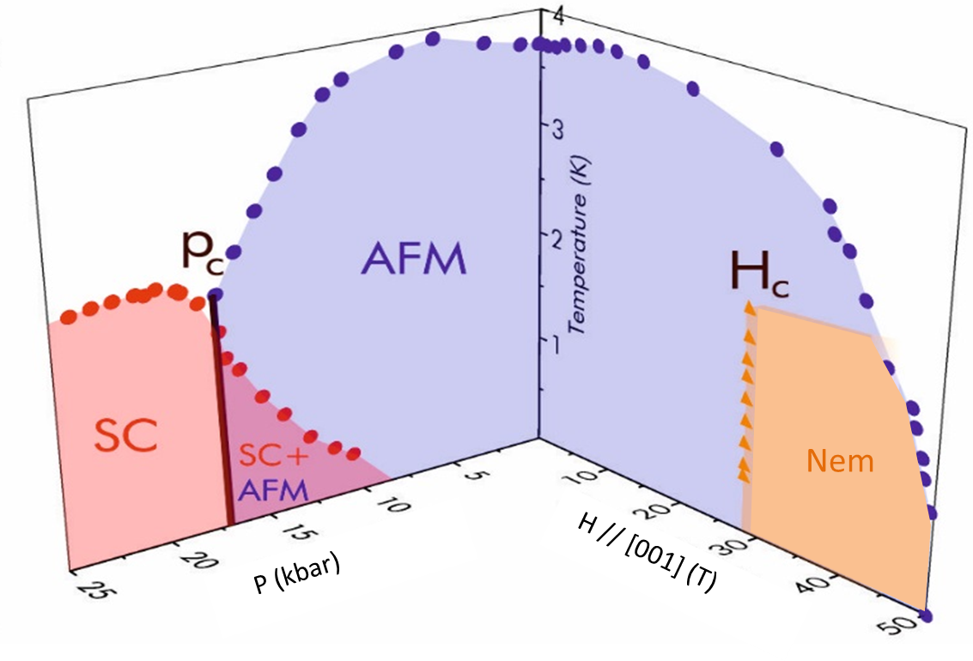

H-P-T phase diagram of CeRhIn₅

